

**• Computers**

**• Laptops**

**• Servers**

**• Printers**

**• LCD Monitors**

**• Printer Ink / Toner**

**• Networking items**

**• Server Racks**

**• Hard Drives**

**• Circuit Boards**

**• Wire**

**• UPS Battery Backups**

**• Computer Accessories**

**• Cable Boxes**

**• Video Game Consoles**

**• Home Electronics**

**• MP3 Players**

**• Cell Phones**

**• Ipad's / Tablets**

**• Video Games**

**• Stereo Equipment**

**• Misc. Electronic**

**www.sbkrecycle.com •**

**6815 26**

**th ST East**

**•**

**Fife**

**,**

**WA**

**98424**

**• 253-539-9095**

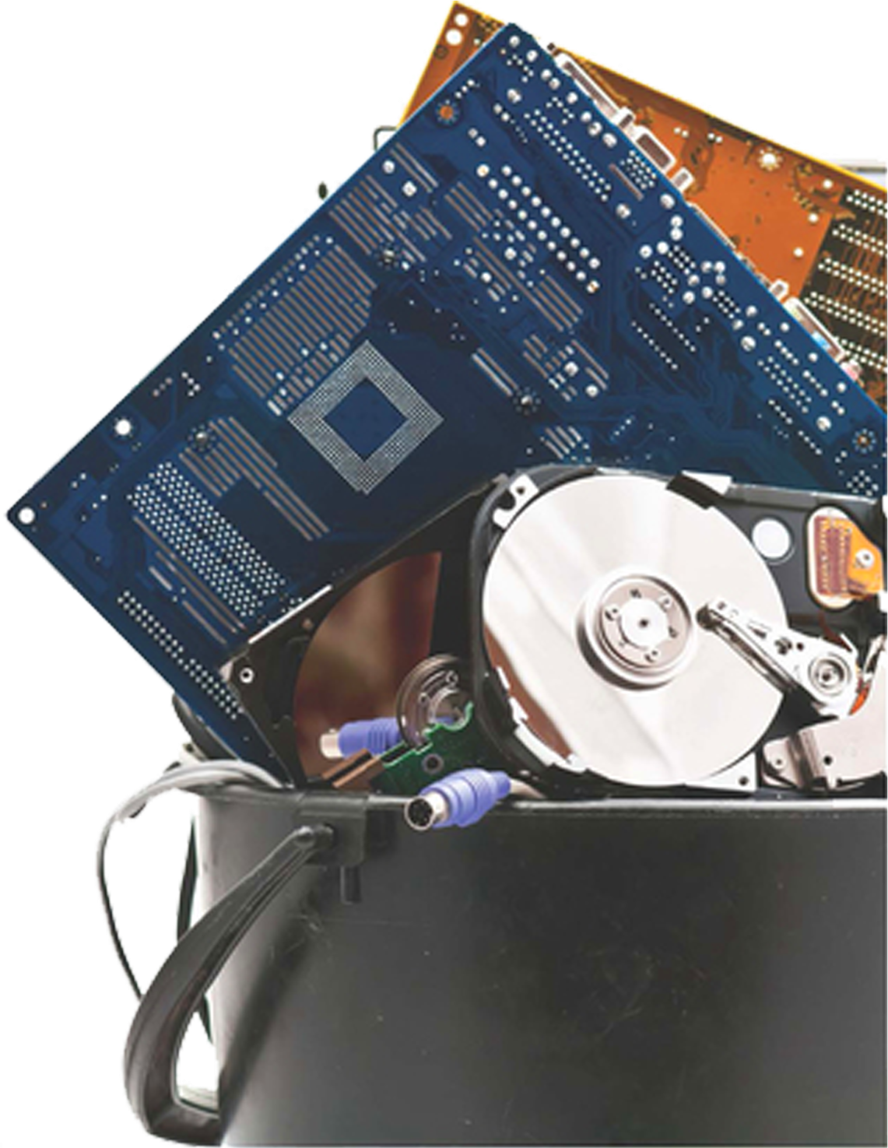

**Presented by:**

**We take all computer &**

**electronic equipment including:**

**Date: Sept 28th, 2024**

**Time: 10:00 to 2:00PM**

Or until both trucks are full so come early.

**Civic Field Parking Lot**

307 S Race St, ·

Port Angeles, WA 98362

**e-Waste**

**Recycling Day**

**We will have 2 trucks for this event. Plenty of room.**

**Fund Raiser for Olympic Kiwanis**

**Donations will be used for funding community projects, student scholarship and foster care support.**

Olympic

